

INSTITUTE OF COMPUTER SCIENCE AND DIGITAL INNOVATION
ASSIGNMENT 1

SUBJECT NAME | Database Design
CODE | BIC2123
LECTURER | Dr. Chloe Thong Chee Ling
Student ID | - 1002163440 Chee Kin Hoe  - 1002475404 Lan Xin Yan

Table of Contents
Entities Attributes Relationships 3
ERD diagram 4
Description 5
Assumptions 6

Entities Attributes Relationships
Entities | Attributes | Relationships
Hospital | Name  Address  Telephone Number | - A Hospital employs many Hospital Doctors
Patient | Name  Address  Telephone Number  Date of birth  ID | - A patient can be either a out-patient or resident patient  - A patient can be one or many resident patient  - A patient can be one or many out-patient  - A patient consults one GP  - A patient visits one hospital doctor
Resident patient | Admission date  Operation history | - One or more resident patient can be a patient  - A resident patient resides in a ward  - A resident patient underwent one or more operations
Out-patient | Diagnosis | - One or more resident patient can be a patient  - An out-patient attends one or more appointments
Hospital doctor | Name  Telephone Number  Specialism code  ID | - A hospital doctor works in a hospital  - A hospital doctor treats one or more patient  - A hospital doctor performs one or more operation
（GP）family doctor | Name  Telephone Number  Address  ID | - A GP refers one or more patients
Appointment | Date  Time  ID  Venue | - An appointment is for an out-patient  - An appointment is attended by one or more out-patient  - An appointment is attended by one Hospital Doctor
Operation | Date  Time  Name  Outcome | - An operation is performed on one or more resident-patient  - An operation is done by one hospital doctor
Theatre | Level  Name | - A theatre hosts one or more operations
Ward | Level  Name | - A ward hosts one or more resident patients

ERD diagram
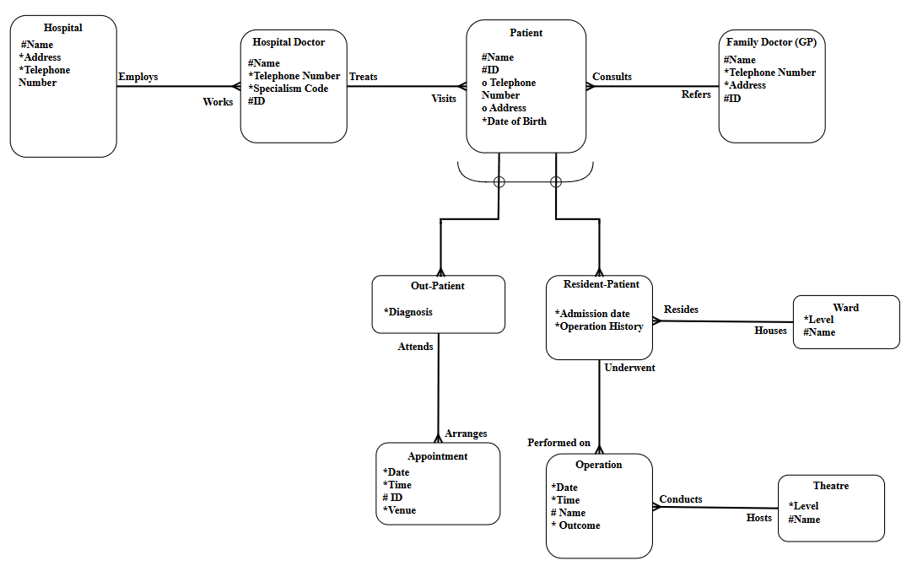

Description
The hospital information system is aimed to handle the data such as doctor, patient and medical operations like operation and appointment. There are two kinds of patients in the system; resident and out-patients. Resident patients refer to those who are admitted to the hospital while the out-patients are those that visit the hospital seeking clinical consultancy or treatments but not being admitted.
The personal data (name, address, telephone number, and date of birth) related to each patient is also characterized. The system has all the doctors grouped into two types: (GP) family doctor who possess an address and doctors in hospitals characterized by specialism code (e.g. ENT in this case ear, nose and throat). The name, ID and telephone number of both types of doctors need to be hold. Hospital doctor directly attached to the patient because both type of patients will visit hospital doctor at hospital. Hospital doctors treat both types of patients at the hospital. Besides, every patient is associated with (GP) a family doctor.
In case of resident patients, the system stores their admission information in the hospital such as the name of the ward they must be admitted to, the date when they have been admitted, and any operation they have already had. The operations are recorded with the date, time, name and outcome. Out-patients have their appointments which are dated, timed, ID and the venue, the diagnosis also will be recorded.
The ward is the place that the resident patient stay at, the level and name of the ward need to be recorded in this system. The theatre is the place that doctor underwent the operation of resident patient. Same as ward, the level and name of theatre will be recorded.

Assumptions
- A hospital must employ more than one hospital doctors.
- One hospital doctor must treats one or more patient, either resident patient or out-patient.
- A Family doctor (GP) have many patients,
- A patient only consults one family doctor.
- A patient visits one hospital doctor only.
- A resident patient can underwent multiple operations.
- Each out-patient can have multiple appointments.
- One ward can house more than one resident patient.
- One theatre must hosts more than one operation but one operation only can conduct in one theatre.
- Each operation is carried out by one hospital doctor.
- A hospital doctor specializes in one specialism.
- A patient must be either a resident-patient or out-patient

